**Practice Regular Past Tense Verbs**

Talk to your child about what the children did yesterday.

Point to each child and use the sentence, **“Yesterday he/she _____”.**

Don’t forget to put your “ED” ending sound on!

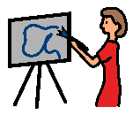 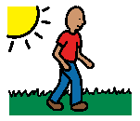  

  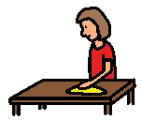 

 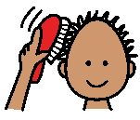  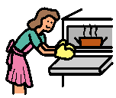

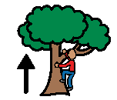 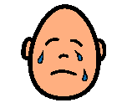 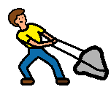 

Now you are ready to practice with your favorite book! Stop after reading each page, look at the pictures and talk about what the characters did. Remember to add “ed” at the end.

**Extended Activity**

Sometimes when we add an “ed” to the end of the word to talk about what happened it sounds like “d” (climbed), but sometimes it sounds like “t” (brushed).

Cut out the pictures and place them on the “D” or the “T” depending on how they sound when you say them.

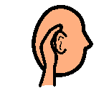 

**D**  **T**