Increase Vocabulary in the Winter!
Name 3-5…
Things that are cold
Toys
Things you wear when it’s cold
Things you do in the snow
Things at the North Pole
Animals that live in cold weather/Arctic animals
Things you put on a Christmas tree
Things that are green
Things that are red

Describe these words using the cues at the bottom of the page…
Cookie Reindeer Snowman Sled Candy Cane Boots
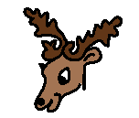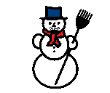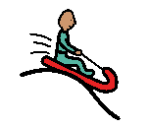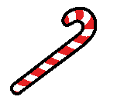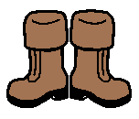

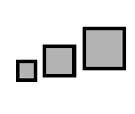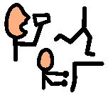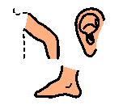
What color is it? What shape is it? What size is it? What does it feel like? Where do you find it? What do you do with it? What parts does it have?

