Increase Vocabulary in the Fall!
Name 3-5…
Things at school
Fruits
Vegetables
Things you see outside
Things you see on Halloween
Things that are sweet
Things you eat at Thanksgiving
Farm animals

Describe these words using the cues at the bottom of the page…
Turkey Pumpkin Leaf Apple Cow
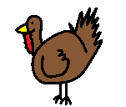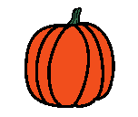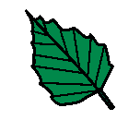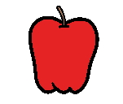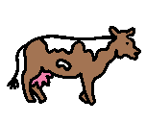

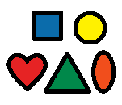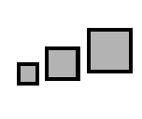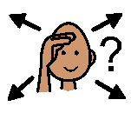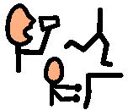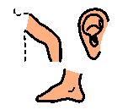
What color is it? What shape is it? What size is it? What does it feel like? Where do you find it? What do you do with it? What parts does it have?

