Increase Vocabulary in the Spring!
Name 3-5…
Bugs
Tools
Things you see in the sky
Things you see on St. Patrick’s Day
Things you see on Easter
Forest Animals
Flowers
Transportation/Things that go
Things at the park

Describe these words using the cues at the bottom of the page…
Butterfly Leprechaun Bunny Tulip Rainbow Hammer
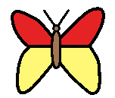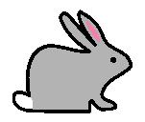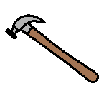

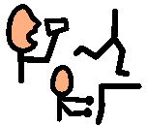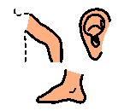
What color is it? What shape is it? What size is it? What does it feel like? Where do you find it? What do you do with it? What parts does it have?

